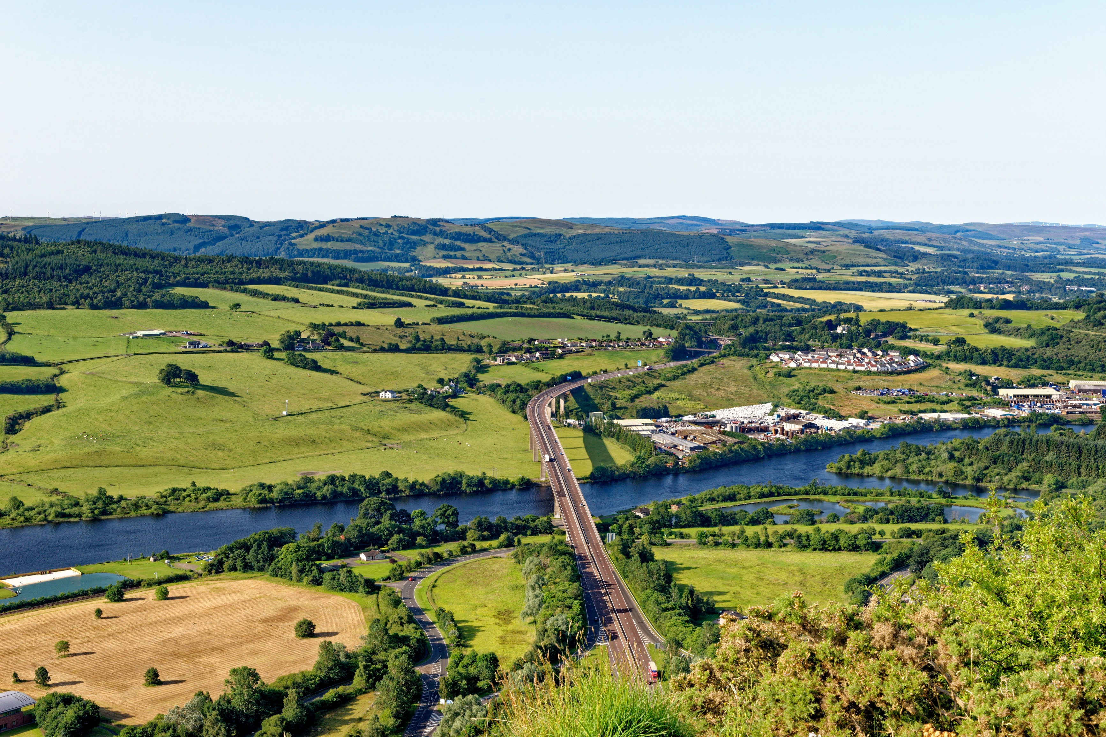

V2.0 March 2025

**Trial Protocols**



|  |  |
| --- | --- |
| **TITLE:** | Centre of Excellence for Decarbonising Roads Trial Protocols |
| **DATE CREATED:** | June 2024 |
| **AUTHOR(s):** | Joseph Webster – Transport for West Midlands |
| **EDITOR:** | Lauren SeBlonka – Amey |
| **REVIEWERS:** | Joseph Kimberley – Colas  Jake Harrison – Amey  Prof. Gordon Airey – University of Nottingham  Simon Wilson – Future Highways Research Group |

This document acts as a guide for future trials lead by the Centre of Excellence, highlighting how a ‘gold standard’ trial would be conducted to provide valuable and feasible data to the local roads sector. This will also act as a guide for wider trials led by local authorities across the UK, enabling them to collate and collect data consistent with our own. Creating valid, harmonious carbon data across the network.

# Table of Contents

Table of Contents 3

1. Introduction 4

2. Trial Planning Process 5

3. The Eight Key Areas for Designing a Trial 7

3.1 Documentation of trials 7

3.2 Contextual trial data 7

3.2.1 Site selection recommendations 8

3.3 Carbon 9

3.4 Monitoring and evaluation 9

3.5 Operational 10

3.6 Data validation 10

3.7 Cost 11

3.8 Procurement 11

3.9 Other 11

4. Trial Checklist 12

# Introduction

The Centre of Excellence for Decarbonising Roads (CEDR) is part of the ADEPT Live Labs 2: decarbonising local roads programme, a three year £30 million UK-wide initiative, funded by the Department for Transport that aims to decarbonise the local highway network. CEDR is a hub for research and innovation for the decarbonisation of local roads materials, developing a knowledge bank, real-life conditions testing and sharing and learning insights.

As the highways and local roads sector faces a plethora of ‘greenwash,’ and the rising pressure to achieve net zero, it is imperative that local authorities have access to reliable, validated data from material trials to enable accurate carbon-based decision-making when designing the roads of the future.

To support credible, science-based material decisions when decarbonising, the Centre of Excellence for Decarbonising Roads (‘the Centre’) has developed the following trial protocols. Chiefly, this document provides internal guidance to the Centre’s delivery team to enable valuable outputs to the sector that fairly measure the carbon, technical and operational performance of materials. This is integral to the programme’s ambition to provide material evaluations that are trusted by local authorities and empower others to adopt low-carbon solutions. Moreover, this document provides guidance to other local authorities seeking to carry out trials capable of providing sufficient data to rigorously determine material success or failure, rather than anecdotal evidence. Should the sector strive towards a collective goal of controlled, rigorous live trials, the transition to low-carbon materials will be significantly smoother and rooted in credible performance data.

At a high-level, this document will firstly define the key steps in the trial planning process, clarifying where the Centre’s team and other LAs should employ the guidance outlined in the trial protocols. Then, the document will describe the eight areas for consideration when designing and implementing a trial on the live road network to support material evaluations. To track and evidence achievement against these eight areas, a checklist is provided.

# Trial Planning Process

Once the team have selected the solution(s) (Potentially through an agreed innovation prioritisation process and scorecard), the trial planning and design must commence. Although live trials yield critical, real-life performance information, the delivery of trials causes certain challenges to local authorities. From time-intensity, coordination of suppliers, innovation procurement and appropriate site selection, the efforts required to successfully trial cannot be underestimated.

To alleviate some of these pressures and streamline the journey from solution identification to live trial, the Centre’s five-step process provides a high-level framework:

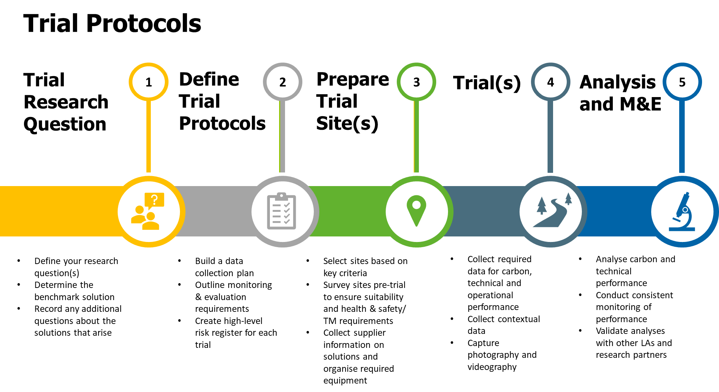

Figure : Trial Planning Process

The constituent parts can be defined as:

|  |  |  |  |  |
| --- | --- | --- | --- | --- |
| STEP | WHY | WHAT | | ESTIMATED TIME |
| 1. Trial Research Question | To ensure the trial has clear objectives and the subsequent trial design is suitable to answer the research questions. | • Define your research question(s) | What do you want to learn from the trial?  What information are you planning to publish?  What decisions do you hope will be impacted by the trial results? | 1 week |
| • Determine your benchmark solution | What do you, as a LA, currently use instead?  Is the benchmark ‘doing nothing’? E.g. for rejuvenators  What do other LAs across the UK use for this material type? |
| • Record any additional questions about the solutions that arise | Beyond the research question(s), what else do you or others in the sector want to know as a result of this trial?  How feasible is it for the trial to answer these questions without compromising the ability to answer the core research question(s)? |
| 2. Define Trial Protocols | To forward plan for consistent, comprehensive and sustained data collection | • Build a data collection plan | What data is required to answer the core research question(s)? Refer to Section 3.  Where will this data be stored?  Who will be responsible for collecting this data?  What special arrangements are required to collect this data? E.g. sub-contractors for specific testing regimes | 2 weeks |
| • Outline monitoring & evaluation requirements | What data will be required for ongoing monitoring and evaluation of the solution’s performance?  How often will this data be collected?  Where will it be stored?  Who will be responsible for collecting M&E data? |
| • Create high-level risk register for each trial | What are the key risks facing this trial, including risks to the LA, contractors, suppliers, road users, pedestrians and the wider programme?  How will these risks be mitigated?  What is their likelihood and impact if they occur? |
| 3. Prepare Trial Site(s) | To identify suitable trial sites and adequately prepare the sites for trial | • Select sites based on key criteria | What road types, conditions and areas are required to answer the core research question(s) and provide confidence in results? | 4 weeks |
| • Survey sites pre-trial | Are there any specialised health and safety and/or traffic management requirements to conduct this trial?  Is there any signage required to notify the public of the works? |
| • Collect supplier information on solutions and organise required equipment | What data is required from the supplier to conduct the trial and answer the core research question(s)? E.g. storage, installation, embodied carbon factors. |
| 4. Trial(s) | To collect real-world data on the live road network to answer the core research question(s) | • Collect required data for carbon, technical and operational performance | Refer to data collection plan and Section 3  Are there any specialised health and safety  requirements to conduct this trial? | Dependent on material |
| • Collect contextual data | Refer to data collection plan and Section 3 |
| • Capture photography and videography | Refer to Section 3 |
| 5. Analysis and M&E | To share trial results and evaluation findings, including observed long-term performance through M&E | • Analyse carbon and technical performance | What does the data reveal about the solution?  How does the trial data answer the core research question(s)? | Dependent on material |
| • Conduct consistent monitoring of performance | Refer to M&E plan |
| • Validate analyses with other LAs and research partners | How do other LAs and research partners interpret the results?  What improvements could be made to the analyses? |

# The Eight Key Areas for Designing a Trial

To design and deliver a credible and valuable live trial of a low-carbon solution, the Centre has outlined eight key areas to consider, with a specific focus on the data and design specifications needed to meet LA needs when selecting materials.

## Documentation of trials

Foremost, rigorous documentation of the trials supports the ability of other LAs to understand the implications of adopting certain low-carbon solutions, whilst simultaneously helping the industry to grow their solutions. There are two key areas to achieve a ‘gold standard’ in documentation:

1. **Videography of the process**

* *What does videography provide?*
  + Verification of contextual and carbon data collected. It will help to eliminate the risk of human error if, for example, the traffic flow was incorrectly counted, or the data collector was distracted and incorrectly measured the amount of material used. It will also provide exact timestamps of when the machinery was used, improving the accuracy of the carbon calculations.
  + Provides a visual aid for the team to use if any stakeholders are curious about methodology, process, location, conditions, PPE, etc.
  + Defend against any negative claims of the trial process. If a supplier’s material performs poorly, they may claim this was due to incorrect methods, the operator's error, or contextual factors of the location. A video of the process would be indisputable evidence against some claims, increasing the confidence and validity of the data.

1. **Photography before and after the trial**

* *What does photography provide?*
  + Demonstrates the efficacy or unsuitability of a product; alongside further contextual data such as, water pooling in the defect, irregular shape of defect, weather condition, road condition, or depth.
  + Ease of distribution and viewing of the material. Photography is an easily digestible format to share with the wider sector, particularly LAs with limited time to read full research reports or watch lengthy videos.

## Contextual trial data

Contextual trial data is an extremely important area to capture to ensure outputs are relatable to different local authorities. It provides a broader understanding of the trials, materials, process, and reasons for failure or success.

Although not exhaustive, the following list details examples of data for contextualising live trial evaluations:

|  |  |
| --- | --- |
| **DATA RECOMMENDATIONS** | |
| Date of trial | Distance from quarry and/or batching plant |
| Road class | Quality control available (record of material temperatures, layer depths, etc.) |
| Road traffic | Pre/post coring records |
| Road speed limit | Experience of operatives with material |
| Road width | Any post-works testing |
| Details of specified works (surface course, binder course depth, inlay/overlay) | Inspection records |
| AADT | Remedial work records |
| Surface area | Details of conflicting works (PUs) |
| Temperature and weather on the day | Cost per metre (or other standard unit for material) |
| Contractor and any other partner organisations | Size of scheme and/or defect |
| Site location (coordinates and/or What Three Words) | Selection criteria for trial sites |

### 3.2.1 Site selection recommendations

When surveying and selecting trial sites, there are key components to ensuring reliable results that fairly reflect the solution’s performance:

* **Representativeness.** Ensuring the road types and sites selected are typical of real UK road conditions is essential. It will ensure a fair trial and increase the operational validity of our data.
* **Exclusion of underlying variables.** Where possible, it is advisable to select roads without major underlying faults. This minimises the risk of trial failure being caused by unknown influences, especially if the trials are surface level activities.
* **Comparative analysis**. By selecting a wide range of sites across a variety of road types, you can ensure all bases for analysis are covered. Some materials may perform better on slower speed, higher HGV roads due to flexibility. Whereas others may perform better on high speed, low HGV roads. It ensures all materials get fair representation. Trial designs should ideally include at least the three main local road classifications (A, B and C).
* **Public disruption.** As is the case with all road works, there must be consideration of the disruption caused to the public when selecting sites. This is particularly notable for materials that have a risk of failure and would require significant remediation.
* **Utilities protection.** Protecting the road ensures that the trial data remains accurate and uncontaminated by external factors. Utilities works could alter the surface, making it difficult to assess the true performance of the new material. It maintains the consistency of the test conditions, which is crucial for comparing the performance of the new material against baseline or innovative materials/processes.
* **Risk mitigation.** Dependent on the technological readiness of the solution, different sites may need to be selected to mitigate any risk to road users should failure occur. For example, if the material has not yet been proven on a live road network, it is advisable to develop a trial programme that commences with a car park or unclassified road, followed by C, B and then A once proven.

## Carbon

As the Centre’s trials are centred around low-carbon materials and methods, obtaining carbon data and ensuring its validity is essential. For evidence-based decision-making towards decarbonisation, there are three areas related to carbon that need to be captured or evaluated during live trials:

1. **A suitable baseline material or method**

* Data on materials helps improve the standardisation of comparative analysis between existing materials and new innovative materials. This comparison is essential for evaluating the longevity, cost, effectiveness, and carbon of new materials. By benchmarking carbon against a standard baseline, any carbon savings potential of the trialled solution can be determined.

1. **A comprehensive carbon statement or Environmental Product Declaration (EPD).**

* LAs face the challenge of navigating ‘greenwash’ and inaccurate carbon statements from material suppliers. If applicable, ensuring supplier data received is valid and further encouraging the verification of carbon through EPDs, live trial findings can further evidence-based decarbonisation.

1. **Whole-lifecycle carbon evaluation**

* Evaluating carbon on a whole-life basis prevents the omission of potentially significant sources of emissions from the material/method used in the trial. A material may have less initial operational carbon, however over its life cycle, due to embedded carbon or very little longevity, it may have more overall emissions.

## Monitoring and evaluation

To regularly assess the long-term performance of the trial, an appropriate monitoring and evaluation programme is required. The frequency of assessments, data types and further testing depend on the material type, the core research questions and the level of rigour required. To support in determining and delivering the M&E programme for the trial, a few considerations are crucial:

* **Develop a tailored monitoring and evaluation programme based on best practice for that material type**. This should be sourced with support from industry bodies, other LAs and research partners.
* **Keep in mind the feasibility**. LAs should consider the capacity of inspectors and agree a feasible route and collection plan.
* **Integrate with existing systems and processes**. If there is a digital platform currently in use for inspections and asset management, monitoring and evaluation data should ideally integrate within this system.
* **Independently evaluate the monitoring and evaluation findings** with academics and/or LAs. This ensures the data is impartial and academically validated.

## Operational

Gathering correct operational data is necessary to assess the operational impacts and viability of the trialled solution for local roads. Examples of this data type may include:

* Accurate time measurements of when machines are in use and the total time taken to undergo the scheme
* All materials used on site (quantity and volume)
* How the material was transported to both the site and depot, including distance travelled
* All vehicles present on site, including fuel type, registrations and distance travelled
* Operatives required to install the material on site
* Waste taken off site, including to where and which vehicle used
* Proof of compliance with supplier standards for application
* Qualitative feedback from operatives on the solution compared to the BAU baseline

Accurately gathering operational data and seeking the perspectives of operational teams ensures the live trial provides valuable information to LAs seeking to transition a material to business-as-usual. Benefits of operational data are:

1. Details any cost implications due to impacts on operational efficiency and/or effectiveness. If a low-carbon solution can only undergo three schemes in the time a BAU solution can undergo 6, then LAs may be less likely to implement this solution.
2. Details can inform any requisite road closures or traffic management to implement the solution.
3. Any barriers to a solution’s transition to BAU can be identified and addressed through the Centre or other LA programmes of support.

## Data validation

External validation is integral to the Centre’s approach to material evaluation and to a collective approach to decarbonisation best practice within the highways and local roads sector. Validation should ideally occur at multiple phases within the trial design and delivery process, including:

1. **The specific trials aim/objective and hypothesis –** clarifying the core research questions. Validation at this stage enables the trial to consider and answer queries stakeholders may have regarding the solution, whilst sense-checking the direction of the trial design before planning commences.
2. **Trial site selection** – a minimal of three representative trial sites is needed for standardisation and comparative purposes. Validation from other LAs and research organisations ensures the trial design gives an accurate representation of UK roads and increases the operational data of the trials.
3. **Validation of approvals and supplier certification** – this validates any claims suppliers may have about their products and prevents greenwashing and false information.

## Cost

Due to tight budget constraints across most LAs in the UK, cost plays a significant role in whether or not a solution can be realistically implemented to business-as-usual. Trials should seek to gather the following cost information:

* The approximate real-life cost to purchase the product if it was used as BAU.
* The whole lifecycle cost, including potentially replacing the solution if needed.
* The costs associated with maintenance/ownership of the solution.
* Potential price volatility of the solution.
* Surety of supply (e.g., if implemented as BAU but suddenly unavailable, LAs may face significant costs to source alternatives).

Gathering this information is critical to low-carbon decisions and developing the case for upfront investment in decarbonisation for long-term savings in carbon and cost.

## Procurement

When local authorities gather and present data for individual/isolated low-carbon innovation trials, information related to the procurement process should be documented. This should include:

* **How the material was procured** (e.g. Whether through a term maintenance contractor, the LCRIG Innovation Procurement System, etc.).
* **Any difficulty/blockers** with procuring this innovation.
* **Level of ease** for procurement of this innovation (1-10).

Gathering this information and providing an 'ease score' would provide valuable information to LA's seeking to potentially procure/trial this innovation themselves.

## Other

There is other data that, whilst hard to categorise, is important to gather. The miscellaneous data that may be considered for collection includes:

* **Additional environmental factors** impacted, such as impacts on vegetation, biodiversity, water pollution or other ecological ceilings.
* **Any recorded impacts on the local community**, such as increased disruption to increased traffic management requirements.
* **Health and safety implications**, such as reduced risk of injury to operational teams due to reduced material temperatures.

# 

# Trial Checklist

Contextual data

☐ Site locations

☐ Site selection criteria

☐ Digital copy of Trial Data collection form (Contextual Section)

Carbon data

☐ Suitable baseline material and/or method

☐ A comprehensive carbon statement or EPD from supplier if necessary

☐ Evaluating selected material/process son a whole life basis

Operational data

☐ All materials and vehicles present at trials.

☐ Digital data collection form (Operational Section)

☐ Accurate timings for all processes/trials

☐ Vehicle/transport to site usage

Monitoring and evaluation data

☐ The material is being independently evaluated by academics/LA’s.

☐ A monitoring programme specific to the material based on best practice.

Cost

☐ Cost of product and delivery for BAU

☐ Whole lifecycle cost calculation

☐ Maintenance/ownership costs

Data validation

☐ Aim/hypothesis and core research questions

☐ Minimum of 3 trial sites

☐ Evidence of approvals and certifications

Documentation

☐ Before and after photo of the defect

☐ Videography of the process

Other

☐ Additional environmental impacts

☐ Any recorded impacts on the local community

☐ Health and safety implications

☐ A comparable and transparent design methodology

To submit your low-carbon solution for consideration within our materials testing programme, or to get in touch with our team to discuss the Centre, follow the link shown: <https://decarbonisingroads.co.uk/>

For more information on ‘Live Labs 2: Decarbonising Local Road in the UK’, follow the link shown: <https://www.adeptnet.org.uk/livelabs2>