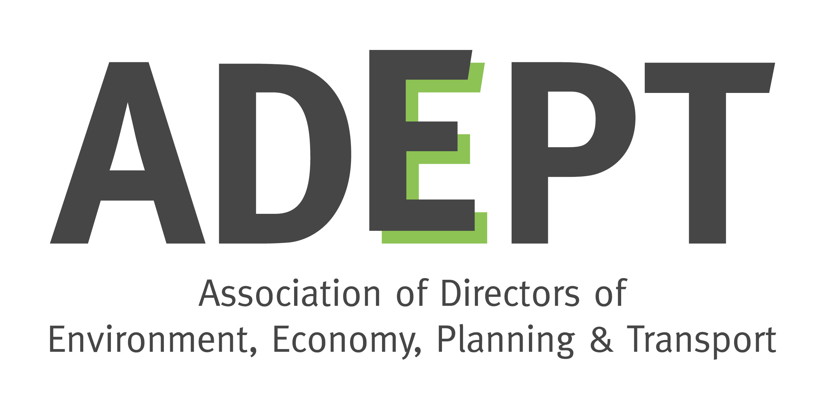
ADEPT Environment Board
Terms of reference (updated November 2018)

Background

The Association of Directors of Environment, Economy, Planning and Transport (ADEPT) represents Place Directors from county, unitary and metropolitan authorities, along with Local Enterprise Partnerships and corporate partners drawn from key service sectors. ADEPT members are at the very heart of maximising sustainable growth in communities throughout the UK. We are delivering the projects that are key to unlocking broader economic success and creating more resilient communities, economies and infrastructure.

The Environment Board

Remit

The Environment Board takes the ADEPT lead on key environmental discussions, providing a greater understanding of the strategic issues and policies relating to the environment. The Board understands that growth and the environment are not mutually exclusive and sustainable growth requires good quality environmental planning, investment and infrastructure, with environmental matters at the heart of decision making.

The Environment Board has a broad and diverse remit, covering some of the cross-cutting issues which do not sit neatly under the other subject Boards. Its remit includes:
- Waste management
- Flood & water management
- Energy
- Natural Capital & heritage
- Climate change resilience and adaptation
- Air quality
- Smart and sustainable approaches to environmental services and planning.

The Board’s agenda is currently driven by the Government’s 25 Year Environment Plan (published in January 2018) and the new environmental legislation and regulations that are being developed for when the UK has left the EU.

Membership

The Board’s membership is voluntary and is drawn from Directors and Heads of Service at member local authorities. It also includes representatives from:
- relevant Government departments – DEFRA and BEIS
- delivery bodies such as the Environment Agency and Natural England
- London Councils/London Environment Directors’ Network (LEDNet)
- ADEPT corporate partners by invitation for specific issues.

Key personnel and current working groups are as follows:
- Board Chair: Paula Hewitt (Somerset, and ADEPT Vice President)
- Deputy Chair: Steve Willis (Lincolnshire)
- Energy Working Group Chair: Carolyn McKenzie (Kent)
- Flood & Water Working Group: Steve Willis (Lincolnshire)
- Waste Working Group: Ian Fielding (North Yorkshire)
- Natural Capital Working Group Chair: Peter Chamberlain (Devon)
- Climate Change Resilience/LAAP: Nigel Riglar (South Gloucestershire).

Meetings and other activities

The Board meets quarterly at venues in central London. Meetings cover updates from Working Groups, updates from Government departments and agencies on current issues, and invited speakers on specific topics. Meetings are usually followed by an afternoon workshop on a specific theme, often lead by one of the Working Groups.

The Board has joint meetings with other ADEPT subject Boards on issues of mutual interest. To date these have been on air quality, with the Transport Board (April 2017), and the National Planning Policy Framework with the Planning, Housing & Regeneration Board (April 2018).

The Board held a joint workshop with an external partner, the Environmental Industries Commission (EIC) in April 2018 on Smart Sustainable Cities, and is looking for further opportunities to have similar events.

In terms of policy development and engaging with Government, the Board submits responses to Government consultations on relevant matters including air quality, water resources, and environmental principles and governance. The Board Chair and Working Group Chairs meet with Ministers and senior officials on an ad hoc basis to discuss current issues.

The Board Chair and Working Group Chairs lead plenary and workshop sessions at the ADEPT annual conference, including natural capital (2016), air quality and energy (2017), and the circular economy (2018). The Chairs also contribute to external conferences and workshops by invitation.

The Board seeks to keep members up to date on current issues, and to share knowledge and best practice between members, by circulating information between meetings.

‘Deep dive’

A report on the Board’s activities, and a stocktake of its strengths and challenges, was submitted to the ADEPT Leadership Team in September 2018 and can be found here.

